Original Research Article

Efficacy of Platelet-Rich Plasma (PRP) in Androgenetic Alopecia, Acne Scars, and Non-Healing Ulcers: A Prospective Interventional Study
Krunal Dudhatra¹, Jui Shah²*, Mansi Pithadia³, Devendra Parmar², Meera Patel⁴,
Prerakkumar Kathiriya⁵

¹Assure Clinic, Ahmedabad, Gujarat, India
²Department of Dermatology, Venereology & Leprosy, Gujarat Adani Institute of Medical Sciences (GAIMS), GK General Hospital, Bhuj, Kutch, Gujarat, India
³Divine Hospital, Jamnagar, Gujarat, India
⁴Vcare Centre of Excellence, Bengaluru, India
⁵Serenity Skin & Aesthetic Clinic, Rajkot, Gujarat, India

* Correspondence: Dr. Jui Shah (juishah13@gmail.com)
ABSTRACT
Background: Platelet-rich plasma (PRP) is an autologous concentrate obtained by differential centrifugation of whole blood, yielding platelets 4–7 times the baseline concentration with an attendant payload of growth factors including PDGF, VEGF, EGF, FGF, TGF-β, and IGF-1, which promote cellular proliferation, collagen synthesis, and tissue regeneration.

Material and methods: A prospective interventional study enrolling 50 patients (20 androgenetic alopecia [AGA], 15 acne scars, 15 non-healing ulcers) was conducted at the Department of DVL, in a tertiary care Centre of western India, from December 2020 to September 2022. PRP was prepared by the manual double-spin method and administered at 15-day intervals for 3 months (6 sessions), with monthly follow-up until 6 months. Outcomes were assessed by physician's global assessment (7-point scale), Hamilton-Norwood/Ludwig grading (AGA), Goodman and Baron's scale (acne scars), and wound area and volume measurements.

Results: In AGA, 85% showed improvement (mild 45%, moderate 30%, excellent 10%). In acne scars, 73.3% achieved a good-to-excellent response (reduction of at least one Goodman and Baron grade); 26–50% improvement was most frequent (53.3%). In non-healing ulcers, mean wound area reduced by 57.4% (14.09 cm² to 6.01 cm²) and volume by 66.0% (4.74 cm³ to 1.61 cm³), and 46.7% of patients rated their response as excellent. No serious adverse events were recorded in any group.

Conclusion: PRP is a safe, cost-effective, and efficacious autologous treatment for androgenetic alopecia, acne scars, and non-healing ulcers with a favorable side-effect profile.

Keywords: Platelet-rich plasma, androgenetic alopecia, acne scars, non-healing ulcer, growth factors

INTRODUCTION
Platelet-rich plasma (PRP) is an autologous concentrate obtained by differential centrifugation of whole blood in which the platelet count is raised to 4–7 times the physiological baseline. The platelets carry a diverse payload of biologically active molecules within their α-granules, including platelet-derived growth factor (PDGF), vascular endothelial growth factor (VEGF), epidermal growth factor (EGF), basic fibroblast growth factor (bFGF), transforming growth factor-β (TGF-β), and insulin-like growth factor-1 (IGF-1).^{1,2} Upon activation — achieved here by calcium chloride — these growth factors are released and bind specific transmembrane receptors on mesenchymal stem cells, fibroblasts, keratinocytes, and endothelial cells, triggering intracellular signal transduction cascades that drive cellular proliferation, differentiation, chemotaxis, angiogenesis, and extracellular matrix synthesis.³ Because PRP is derived from the patient's own blood, it carries no risk of immunological rejection or cross-contamination, and its preparation is simple, inexpensive, and office-based.
Androgenetic alopecia (AGA) is the commonest form of hair loss worldwide, affecting up to 50% of men by the age of 50 years⁴ and approximately 30–40% of women by the age of 70.⁵ Conventional therapies require long-term compliance and carry recognised side-effect profiles, creating clinical demand for safe adjunct or alternative treatments.
Acne vulgaris produces atrophic scarring with significant psychosocial consequences in young adults.⁶ Standard scar therapies — dermabrasion, laser resurfacing, and chemical peels — are variably effective, expensive, and carry risks of post-inflammatory hyperpigmentation particularly in darker skin phototypes, which predominate in the Indian subcontinent.
Chronic non-healing ulcers are characterised by proteolytic wound-bed degradation, persistent inflammation, and growth-factor depletion.⁷ PRP's multi-factorial regenerative mechanism makes it uniquely suited to address these deficits.
While individual studies have examined PRP in each condition, simultaneous prospective evaluation across three dermatological indications in a single Indian tertiary care cohort is lacking. This study prospectively assessed the clinical efficacy, safety, and patient satisfaction of PRP in patients with AGA, acne scars, and non-healing ulcers at a tertiary care centre in western India.
MATERIAL AND METHODS
This was a prospective interventional study conducted at the Department of DVL, in a tertiary care centre of western India, over a period of approximately 22 months from December 2020 to September 2022. The study protocol was approved by the Institutional Ethics Committee (IEC approval reference: IEC/RESCH/2021/28). Written informed consent was obtained from all participants before enrolment, in accordance with the Declaration of Helsinki.
Study Population
Fifty patients attending the DVL outpatient department who fulfilled the inclusion criteria were enrolled: 20 with androgenetic alopecia, 15 with atrophic acne scars, and 15 with chronic non-healing ulcers.
Inclusion Criteria
Patients aged 18–80 years who provided written informed consent and were willing to complete the full treatment schedule; AGA of Hamilton-Norwood grade 3 or 4 in males or Ludwig grade 2 or 3 in females; atrophic acne scars of rolling and/or box morphology of any Goodman and Baron qualitative grade; non-healing leg ulcers persisting despite treatment for at least six months.

Exclusion Criteria
Patients with a keloidal tendency; ice-pick acne scars; bleeding tendency or bleeding disorders; patients on anticoagulant medication; active infection at the local site; and a history of psoriasis or lichen planus (risk of Köbner's phenomenon).
Baseline Investigations
All participants underwent complete blood count, serum iron and ferritin, bleeding time, clotting time, prothrombin time, activated partial thromboplastin time (APTT), random blood sugar, HIV and HBsAg prior to the first treatment session.
PRP Preparation
PRP was prepared using the manual double-spin technique as recommended by the National IADVL PRP Taskforce.⁸ Under strict aseptic precautions, 20–30 mL of venous blood was collected into sodium citrate vacutainers. A soft spin (2000 rpm, 5–10 min) separated the buffy coat and plasma from red cells; this fraction was then transferred to a plain vacutainer and subjected to a hard spin (3500–4000 rpm, 10–15 min). The lower platelet-rich layer was retained; the platelet-poor upper fraction was discarded. Immediately before injection, PRP was activated by adding 10% calcium chloride solution at 0.3 mL per 1 mL of PRP.
Treatment Protocol
For AGA, the scalp was prepared with povidone-iodine and normal saline following application of topical anaesthesia. Activated PRP was injected with insulin syringes at 0.1 mL/cm² in a retrograde fashion, from deep to superficial, at every centimeter over the treatment area. In acne scars and non-healing ulcers, activated PRP was injected; in some acne scar patients, PRP was combined with dermaroller microneedling (Figure 2). Six sessions were given at 15-day intervals over three months; patients were assessed every 15 days for the first 3 months and monthly for the next 3 months.
Outcome Assessment
Standardized photographs were obtained at baseline, 3 months, and 6 months with fixed position, angle, lighting, magnification and distance. In AGA, the physician's global assessment on a 7-point scale (−3 to +3) was supplemented by Hamilton-Norwood/Ludwig grading and the hair pull test. In acne scars, Goodman and Baron's qualitative scale was applied (excellent response = 2-grade reduction; good = 1-grade reduction; poor = no change), and the physician also assessed percentage improvement. In non-healing ulcers, clinical response was measured by comparing the pre-treatment and post-treatment area (cm²) and volume (cm³) of the ulcer. Patients graded their satisfaction on a scale of 0–6, with 0 being no satisfaction and 6 complete satisfactions (4–6: excellent; 2–4: good; <2: poor).
Statistics
Data were analyzed using descriptive statistics. Categorical variables are reported as frequencies (percentages) and continuous variables as mean (SD).
RESULTS
Demographic Profile
Of the 50 enrolled patients, 31 (62%) were male and 19 (38%) females, yielding a male-to-female ratio of 1.63:1. The mean (SD) ages were 29.75 (7.00) years in AGA, 24.6 (5.08) years in acne scars and 51.87 (9.54) years in non-healing ulcers, consistent with the established epidemiological profile of each condition. All 50 patients completed the 6-month follow-up.

Group 1: Androgenetic Alopecia (n = 20)
Males constituted 70% (n=14) and females 30% (n=6). Mean (SD) duration of hair loss was 21.2 (16.9) months. Hamilton-Norwood grading in males: Grade 3 in 57.15% (n=8), Grade 4 in 42.85% (n=6). Ludwig grading in females: Grade 3 in 66.66% (n=4), Grade 2 in 33.33% (n=2). Prior treatment was documented in 45% (n=9) and a positive family history in 45% (n=9).
On the physician's global assessment at 6 months (Table 1), 85% of patients showed some improvement and 40% showed moderate-to-excellent improvement. On self-assessment, 10 patients (50%) rated their response as good, 3 (15%) as excellent and 7 (35%) as poor. The hair pull test converted to negative in 9 of 14 initially positive patients (64.3%). Ten patients (50%) had no side effects; the others reported seborrhoeic dermatitis (20%, n=4), pruritus (20%, n=4), headache (15%, n=3), irritation (15%, n=3) or local infection (5%, n=1). No side effect lasted more than 48 hours.
Table- 1: Physician's Global Assessment at 6 Months – Androgenetic Alopecia (n=20)
Physician's Assessment | No. of Patients | Percentage (%)
No Improvement | 3 | 15.0
Mild Improvement | 9 | 45.0
Moderate Improvement | 6 | 30.0
Excellent Improvement | 2 | 10.0
Total | 20 | 100.0

Before Treatment | After Treatment (6 months)
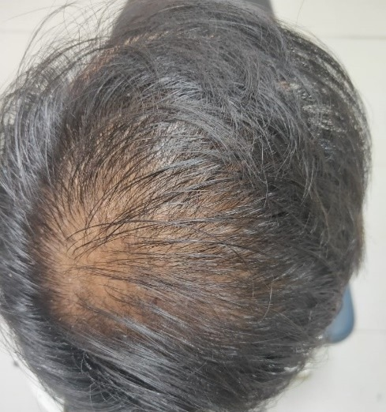 | 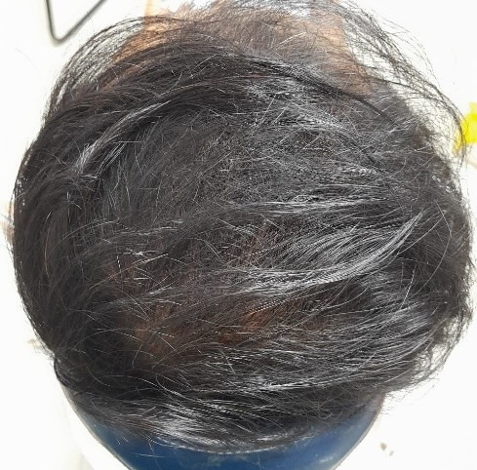
Figure- 1: Case 1 – Male, 25 years. Hamilton-Norwood Grade 3 androgenetic alopecia. Baseline (left) and 6-month follow-up (right) photographs of the vertex showing increased hair density and improved scalp coverage following 6 sessions of PRP. Side effect: transient pruritus.
Group 2: Acne Scars (n = 15)
Males constituted 40% (n=6) and females 60% (n=9); mean age 24.6 years. Scar morphology: rolling 53.3% (n=8), box 20% (n=3), and mixed rolling-and-box 26.7% (n=4). Baseline Goodman and Baron grading: Grade 2 in 13.33% (n=2), Grade 3 in 53.33% (n=8), and Grade 4 in 33.33% (n=5).
At 6 months, the Goodman and Baron grade fell by two grades in 5 patients and by one grade in 6, giving a good-to-excellent response in 73.3% (Table 2); 4 patients showed no change. On the physician's assessment of percentage improvement, 4 patients (26.7%) showed 0–25%, 8 (53.3%) 26–50% and 3 (20.0%) 51–75% improvement. On self-assessment, 2 patients (13.3%) rated their response as excellent, 9 (60.0%) as good and 4 (26.7%) as poor. Procedure-related effects included pain during injection in 60% (n=9), erythema in 53.3% (n=8) and post-inflammatory hyperpigmentation (PIH) in 26.7% (n=4).
Table- 2: Response by Goodman and Baron Grade Reduction at 6 Months – Acne Scars (n=15)
Response (Grade Reduction) | No. of Patients |  | Percentage (%)
Poor Response | 4 |  | 26.7
Good Response | 6 |  | 40.0
Excellent Response | 5 |  | 33.3
Total | 15 |  | 100.0
Before Treatment – Right |  | Before Treatment – Left
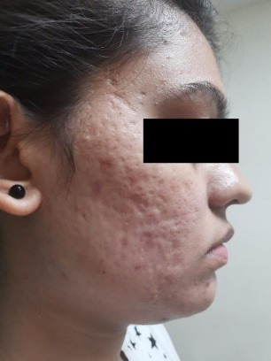 |  | 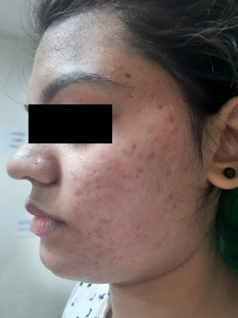
After Treatment (6 months) – Right |  | After Treatment (6 months) – Left
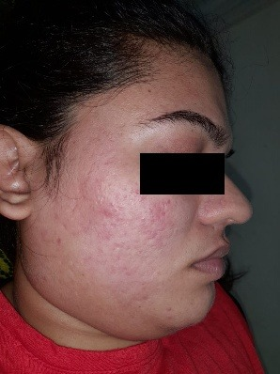 |  | 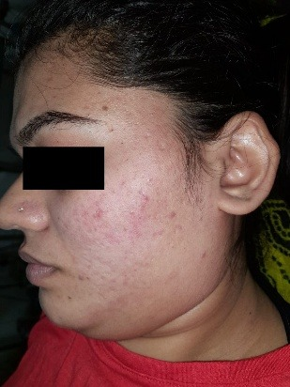
Figure- 2: Case 2 – Female, 26 years. Mixed box-and-rolling acne scars (Goodman & Baron Grade 3). Bilateral facial photographs at baseline (top row) and at 6-month follow-up (bottom row) show reduction in scar depth and improved skin texture following 6 sessions of PRP combined with dermaroller microneedling. Transient pain and erythema were noted post-procedure.
Group 3: Non-Healing Ulcers (n = 15)
Males constituted 73.33% (n=11) and females 26.66% (n=4); mean (SD) age 51.87 (9.54) years. Associated illnesses were present in 53.33% (n=8): leprosy (n=4), diabetes mellitus (n=3) and hypertension (n=1). Prior treatment was documented in 60% (n=9). Mean (SD) ulcer duration was 15.6 (10.1) months.
At 6 months, mean ulcer area and volume had fallen by 57.4% and 66.0% respectively (Table 3). Two patients (13.33%) showed complete or near-complete healing. On self-assessment, 7 patients (46.67%) rated their response as excellent, 4 (26.66%) as good and 4 (26.66%) as poor. Poor responders tended to have larger ulcers, and all four had an associated illness (leprosy in two; diabetes mellitus and hypertension in one each). No adverse effects were observed in this group throughout the study period.
Table- 3: Wound Dimensions Before and After PRP Therapy – Non-Healing Ulcers (n=15)
Parameter | Baseline, Mean (SD) | At 6 Months, Mean (SD) | % Reduction
Ulcer Area (cm²) | 14.09 (4.88) | 6.01 (7.03) | 57.4%
Ulcer Volume (cm³) | 4.74 (3.10) | 1.61 (2.20) | 66.0%

Before Treatment | 3 Months | 6 Months
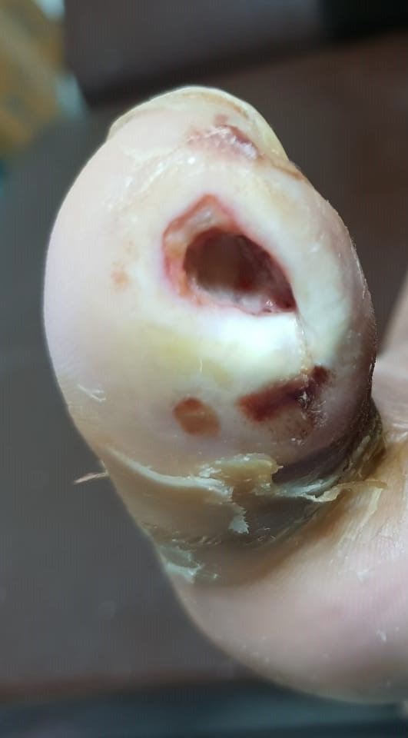 | 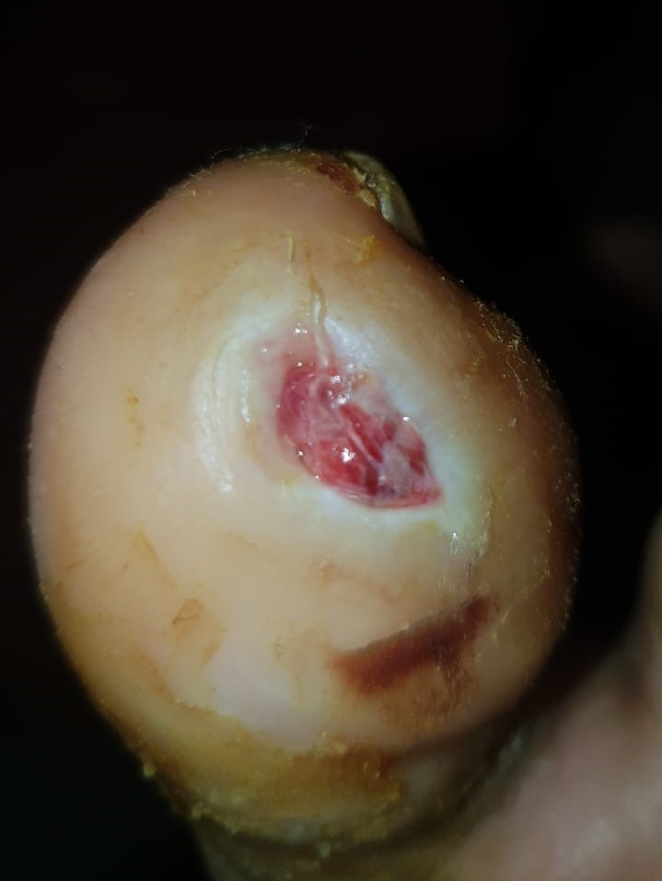 | 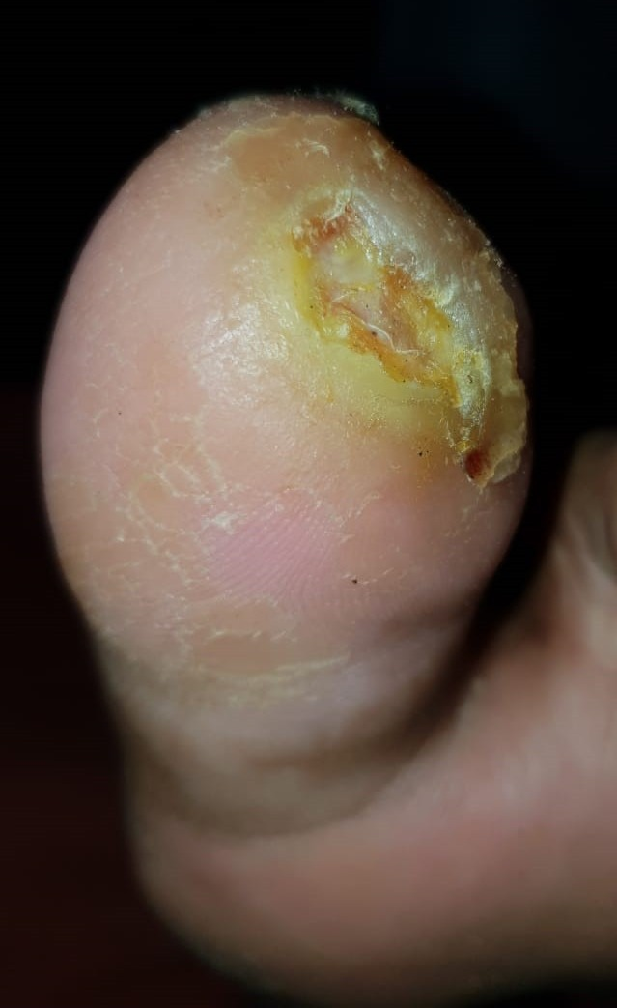
Figure- 3: Case 3 – Female, 36 years. Non-healing ulcer in a patient with leprosy. Sequential photographs at baseline (left), 3 months (centre), and 6 months (right) demonstrate progressive wound contraction, healthy granulation tissue formation, and marked reduction in ulcer dimensions. No procedure-related adverse effects were observed.

DISCUSSION
The rationale for PRP in dermatological wound healing and regeneration is well established: by concentrating autologous growth factors at the site of pathology, it circumvents the growth-factor deficit that characterises chronic wounds and scarred tissue, while the entirely autologous nature of the preparation eliminates any risk of immune reaction or infectious disease transmission.⁹ The present study demonstrates a clinically meaningful response in all three indication groups, with an acceptably low and transient adverse-event profile.
In AGA, PRP is postulated to act via multiple mechanisms: direct stimulation of dermal papilla cell proliferation, upregulation of the anti-apoptotic Bcl-2 and Akt survival pathways, conversion of telogen follicles to anagen, and enhancement of peri-follicular vascularity through PDGF and VEGF.¹⁰ In our cohort, 85% of patients showed some improvement and 40% showed moderate-to-excellent improvement. Schiavone et al. reported some improvement in 62–64 of 64 patients, with 40.6–54.7% reaching a clinically important difference on independent rating of photographs,¹¹ while Gupta et al. reported a mean improvement of 30.2% on independent evaluation of global photographs in 30 men.¹² The mean age of our AGA cohort (29.75 years) was comparable to the 22.8 years reported by Hajheydari et al.¹³ The lower frequency of a positive family history in our patients (45% vs. 81.6% in Hajheydari et al.) may reflect regional genetic heterogeneity. Among men, response was better in Hamilton-Norwood grade 3 than in grade 4, suggesting that preserved follicular reserve favours a better response to PRP.
In acne scars, the mechanism of PRP involves fibroblast activation via TGF-β, PDGF, and VEGF, leading to upregulation of type I and type III collagen synthesis; simultaneously, MMP-1 induction by PRP permits remodelling and clearance of degraded collagen fragments to allow deposition of new, well-organised matrix.¹⁴ Rolling scars predominated in our cohort (53.3%). Wahab et al. reported marked improvement in 42.5% and moderate improvement in 35% of 40 patients treated with PRP monotherapy, comparable to the 33.3% excellent and 40.0% good responses in our series.¹⁵ Post-inflammatory hyperpigmentation occurred in 26.7% of our patients; in a split-face study, Shah et al. found adverse effects to be significantly less frequent on the side treated with PRP.¹⁶ In our series, Grade 4 scars showed the largest mean reduction in grade (1.6 grades), although numbers were small.
In chronic non-healing ulcers, the wound microenvironment is characterised by elevated levels of proteases, persistent inflammation, and relative growth-factor depletion, all of which impair the normal healing cascade.¹⁷ PRP addresses this deficit directly: the fibrin clot formed on activation provides a provisional scaffold for cell migration, while the concentrated growth factors restore the angiogenic and fibroproliferative drive required for progression through the proliferative phase of healing. Our reductions of 57.4% in mean area and 66.0% in mean volume were smaller than the mean improvements of 94.7% in area and 95.6% in volume, with complete healing of 13 of 17 ulcers (76%), reported by Sarvajnamurthy et al. after six weekly applications in a younger cohort (mean age 33.5 years).¹⁸ The difference may partly reflect patient profile: in our series, all four poor responders had an associated illness (leprosy, diabetes mellitus or hypertension), conditions known to impair wound healing. The absence of adverse events in this group supports PRP's safety even in patients with co-morbidities.
The limitations of this study include a small sample size (n=50), absence of a control arm, lack of platelet count quantification per PRP preparation, descriptive analysis without tests of statistical significance, single-centre design, and a 6-month follow-up, which precludes assessment of long-term recurrence. In addition, the ulcer group was heterogeneous in aetiology, including four patients with leprosy, and ulcers were not further classified by cause.

CONCLUSIONS
PRP is a safe, well-tolerated, cost-effective, and clinically efficacious autologous treatment modality for androgenetic alopecia, atrophic acne scars, and non-healing ulcers. Its autologous nature minimises adverse reactions, and its low cost makes it valuable in resource-limited settings. Larger randomised controlled trials with standardised platelet counts and longer follow-up are warranted.

What was already known before this study
– PRP is an autologous concentrate of growth factors that promote tissue repair and regeneration.
– Individual studies have reported benefit of PRP in androgenetic alopecia, atrophic acne scars and chronic ulcers.
– The manual double-spin method is recommended by the National IADVL PRP Taskforce.
What this study adds to existing knowledge
– A single prospective cohort evaluating PRP across three dermatological indications in an Indian tertiary care setting.
– Improvement in 85% of AGA patients, good-to-excellent response in 73.3% of acne scar patients, and 57.4% and 66.0% reductions in mean ulcer area and volume.
– All poor responders in the ulcer group had an associated illness (leprosy, diabetes mellitus or hypertension); side effects across groups were mild and transient.

REFERENCES
- Marx RE, Garg AK. Dental and craniofacial applications of platelet-rich plasma. Chicago: Quintessence Publishing; 2005.

- Flad HD, Brandt E. Platelet-derived chemokines: pathophysiology and therapeutic aspects. Cell Mol Life Sci. 2010;67(14):2363-86.

- Marx RE. Platelet-rich plasma: evidence to support its use. J Oral Maxillofac Surg. 2004;62(4):489-96.

- Norwood OT. Male pattern baldness: classification and incidence. South Med J. 1975;68(11):1359-65.

- Norwood OT. Incidence of female androgenetic alopecia (female pattern alopecia). Dermatol Surg. 2001;27(1):53-4.

- Schachter RJ, Pantel ES, Glassman GM, Zweibelson I. Acne vulgaris and psychologic impact on high school students. N Y State J Med. 1971;71(24):2886-90.

- Agale SV. Chronic leg ulcers: epidemiology, aetiopathogenesis, and management. Ulcers. 2013; 2013:413604.

- Dashore S, Chouhan K, Nanda S, Sharma A. Preparation of platelet-rich plasma: National IADVL PRP Taskforce recommendations. Indian Dermatol Online J. 2021;12(Suppl 1):S12-23.

- Schmitz JP, Hollinger JO. The biology of platelet-rich plasma. J Oral Maxillofac Surg. 2001;59(9):1119-21.

- Khatu SS, More YE, Gokhale NR, Chavhan DC, Bendsure N. Platelet-rich plasma in androgenic alopecia: myth or an effective tool. J Cutan Aesthet Surg. 2014;7(2):107-10.

- Schiavone G, Raskovic D, Greco J, Abeni D. Platelet-rich plasma for androgenetic alopecia: a pilot study. Dermatol Surg. 2014;40(9):1010-9.

- Gupta S, Revathi TN, Sacchidanand S, Nataraj HV. A study of the efficacy of platelet-rich plasma in the treatment of androgenetic alopecia in males. Indian J Dermatol Venereol Leprol. 2017;83(3):412.

- Hajheydari Z, Akbari J, Saeedi M, Shokoohi L. Comparing the therapeutic effects of finasteride gel and tablet in treatment of the androgenetic alopecia. Indian J Dermatol Venereol Leprol. 2009;75(1):47-51.

- Cho JW, Kim SA, Lee KS. Platelet-rich plasma induces increased expression of G1 cell cycle regulators, type I collagen, and matrix metalloproteinase-1 in human skin fibroblasts. Int J Mol Med. 2012;29(1):32-6.

- Wahab AJ, Anandan V, Mani Surya Kumar M, Shukla S. Efficacy and safety of platelet rich plasma (PRP) as monotherapy in the management of acne scars in a tertiary care centre. IP Indian Journal of Clinical and Experimental Dermatology. 2017;3(3):119-23.

- Shah SD, Mehta BD, Borkar MA, Aswani RC. Study of safety and efficacy of autologous platelet rich plasma combined with fractional CO2 laser in the treatment of post acne scars: a comparative simultaneous split-face study. International Journal of Research in Medical Sciences. 2017;5(4):1344-51.

- Suthar M, Gupta S, Bukhari S, Ponemone V. Treatment of chronic non-healing ulcers using autologous platelet rich plasma: a case series. J Biomed Sci. 2017;24(1):16.

- Sarvajnamurthy S, Suryanarayan S, Budamakuntala L, Suresh DH. Autologous platelet rich plasma in chronic venous ulcers: study of 17 cases. J Cutan Aesthet Surg. 2013;6(2):97-9.

Source of support: None
Conflict of interest: None declared
How to cite: Dudhatra K, Shah J, Pithadia M, Parmar D, Patel M, Kathiriya P. Efficacy of Platelet-Rich Plasma (PRP) in Androgenetic Alopecia, Acne Scars, and Non-Healing Ulcers: A Prospective Interventional Study. GAIMS J Med Sci 2027;7(1): 33-41
https://doi.org/10.5281/zenodo.23470605

